LINX RAIL (future)
CANDO RAIL SERVICES
CITY OF BARRIE (current)
PHASE ZERO, LINE S12, BARRIE SOUTH TO ALLANDALE RAIL DIESEL CAR FLEET
SUMMARY
Retaining their Blue and White livery patched over for LINX Rail, these trains will launch the first Made in Barrie, Made in Simcoe, local/urban rail service.

Using existing crews, facilities, and track, these trains, based out of Utopia, will operate daily every 10-15 minutes between Barrie South and Allandale outside of key GO operating hours, with local and LINX fares accepted.

The goal of these trains is to deliver a service to the people of Barrie, and consequently the people of Simcoe County and from farther away who visit us, a cost effective, game changing rail service on a budget comparable to the bus, but extremely competitive against a bus ride or drive up Yonge Street.

The interiors were heavily refurbished in the 1990s for Trinity Rail Express of Fort Worth Texas, but all the cars are of Canadian origin, having run for VIA Rail Canada up until the January cuts of 1990, before being refurbished by Pointe St Charles shops in Montreal, under CN’s manufacturer company, AMF Technotransport.

The trains, even though they’re 1955-1960 models, received a full structure and mechanical rebuild. The controls and mechanicals are modern, dependable and simple 1990s designs that also are quieter than the 1950s engines they came with, and the interiors are bright, comfortable and modern. Most cars come with washrooms onboard, and all are Wheelchair Accessible, through the use of station placed hand crank lifts we would acquire for them.

We will include exhibit photos of an example car, to show you how good they are for us. We recommend these cars due to their Ready to Run nature, and to place them into service with minimal repairs required to operate them.

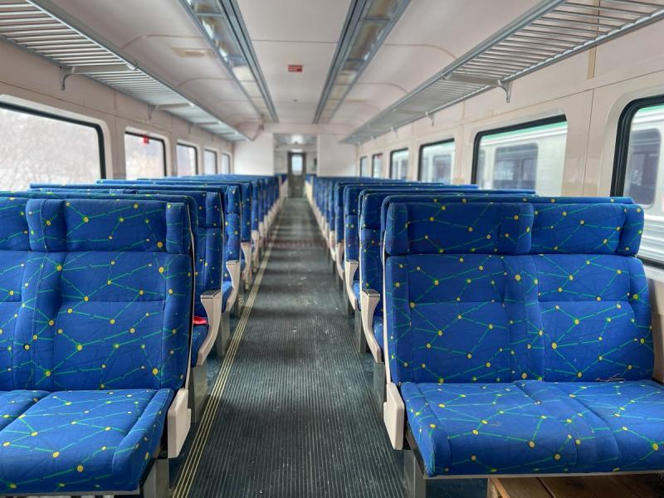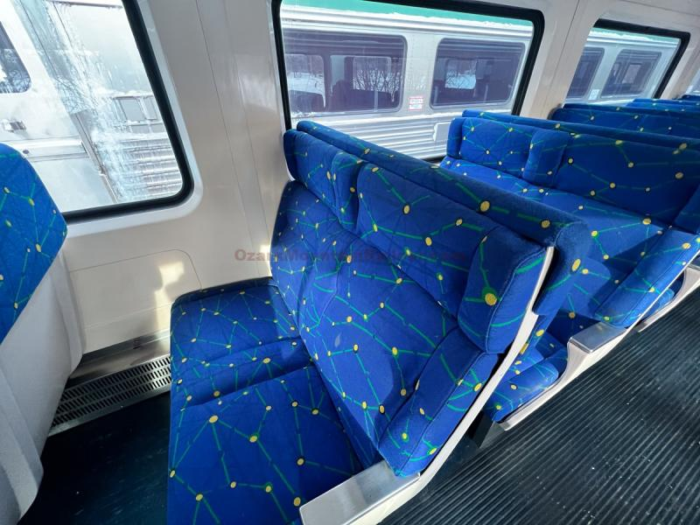
Exhibit A, Interiors

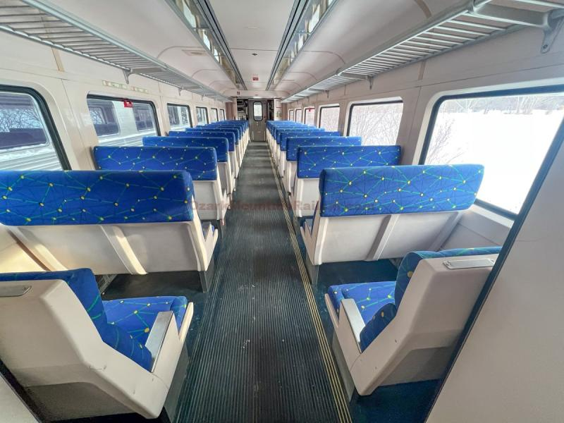
Exhibit B, Midship to Front View

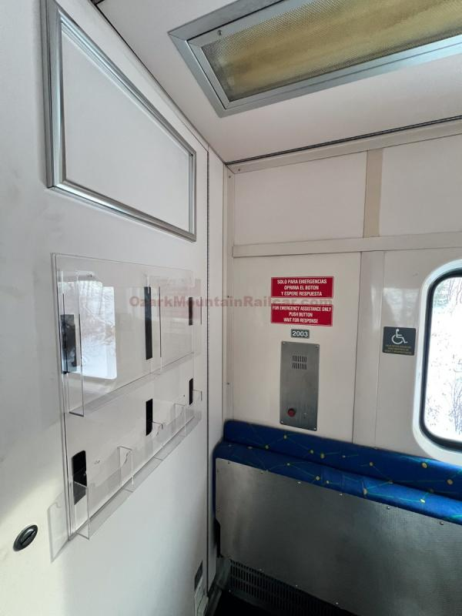
Exhibit C, Accessibility section with fold up seats

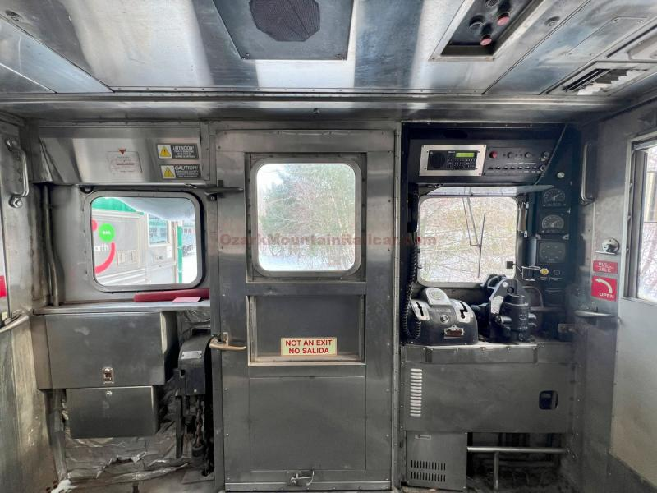
Exhibit D. View of Operator’s Cab facing Forward
The cabs can be collapsed to allow transiting between cars, which we’d allow on our 2 car sets.

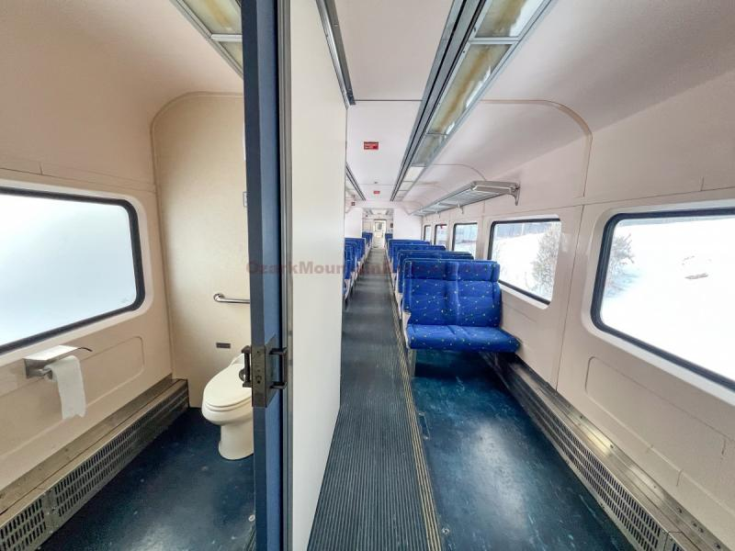
Exhibit F
A car converted to offer a Toilet and full AODA compliant space
Also shows that all our trains have full luggage storage on the ceiling.

BUDD RDC-1, BATCH 1
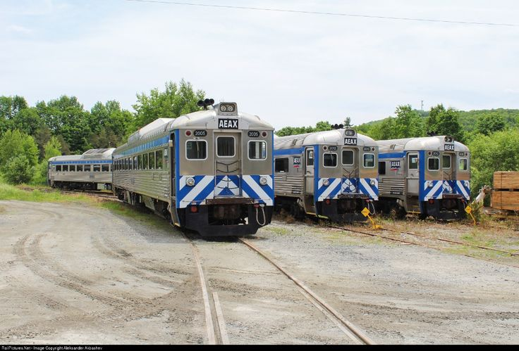
ALL EARTH RAIL AEAX 2001-2013
Rebuilt 1990 AMF-Budd RDC-1
ENGINES: 2x Cummins NTA855R-400hp
TRANSMISSIONS: Allison railway transmissions
SEATS: 90 seated, about 20 standees, room for 4 wheelchairs per car
SPECS: Acquire from All Earth Rail of Vermont, either on a lease or ownership basis. Re-livery to LINXNet livery incorporating yellow noses and blue stripes. Keep current interiors. Eventually buy into whole ownership. Light refurbishment done, with 1990s interior and powertrain retained, but electrical outlets and plugs added.
USES: LINXNet Passenger Rail Pilot. S12 to be assigned non-washroom units/

NOTES: Fleet was in limbo for a decade, though the owners in Vermont did keep them maintained rather than mothballing them.

In February 2025, Ozark Mountain Railcar placed a listing of the entire 12 car fleet of RDCs in Vermont. We highly recommend LINXNet act on these as soon as possible, getting a jump on them, and then simply use what we need, lease out what we don’t. This means that regardless of whether our trains carry our passengers or someone else’s, they’re making money for us, which can be used to fund our expansions, infrastructure programmes and outreach. These are the finest variants of the Budd RDC-1 in existence, with the entire mechanical, electrical and interior components having been stripped and replaced with new components at Pointe St-Charles in 1997 for Trinity Rail Express of Texas.
Here is the listing for your reading

https://ozarkmountainrailcar.com/railEquipment.php?itemId=4122#
https://www.facebook.com/ozarkmountainrailcar/posts/pfbid0224n3fTdiACPpM4cPShxKe84yrEGTkGQ5HBYKs4MzGd2JDLznYigFaLW51aswrxaVl?rdid=SoU6oL4fpRAOe0Bs#

INDIVIDUALS
https://ozarkmountainrailcar.com/railEquipment.php?itemId=4124&category=Passenger%20Equipment
https://ozarkmountainrailcar.com/railEquipment.php?itemId=4125&category=Passenger%20Equipment
https://ozarkmountainrailcar.com/railEquipment.php?itemId=4126&category=Passenger%20Equipment
https://ozarkmountainrailcar.com/railEquipment.php?itemId=4127&category=Passenger%20Equipment
https://ozarkmountainrailcar.com/railEquipment.php?itemId=4128&category=Passenger%20Equipment
https://ozarkmountainrailcar.com/railEquipment.php?itemId=4129&category=Passenger%20Equipment
https://ozarkmountainrailcar.com/railEquipment.php?itemId=4133&category=Passenger%20Equipment
RDC-1
These Individual Cars will be used to launch service
Our bus fleet offers a capacity of 33 per bus. 1 RDC doubles that capacity.

https://ozarkmountainrailcar.com/railEquipment.php?itemId=4143&category=Passenger%20Equipment
RDC-2 with Kitchen
https://ozarkmountainrailcar.com/railEquipment.php?itemId=4144&category=Passenger%20Equipment
RDC-2 with Baggage converted to Wheelchair lift

